**Bookmyshow Jira tool Screenshots**

I have derived 79 test cases for Bookmyshow Project in excel Sheet.

Splited the 79 Test cases into 6 Epics and 13 User Stories. Added Sub-task into the main 13 user Stories.

Attaching the JIRA Screenshots of that below,

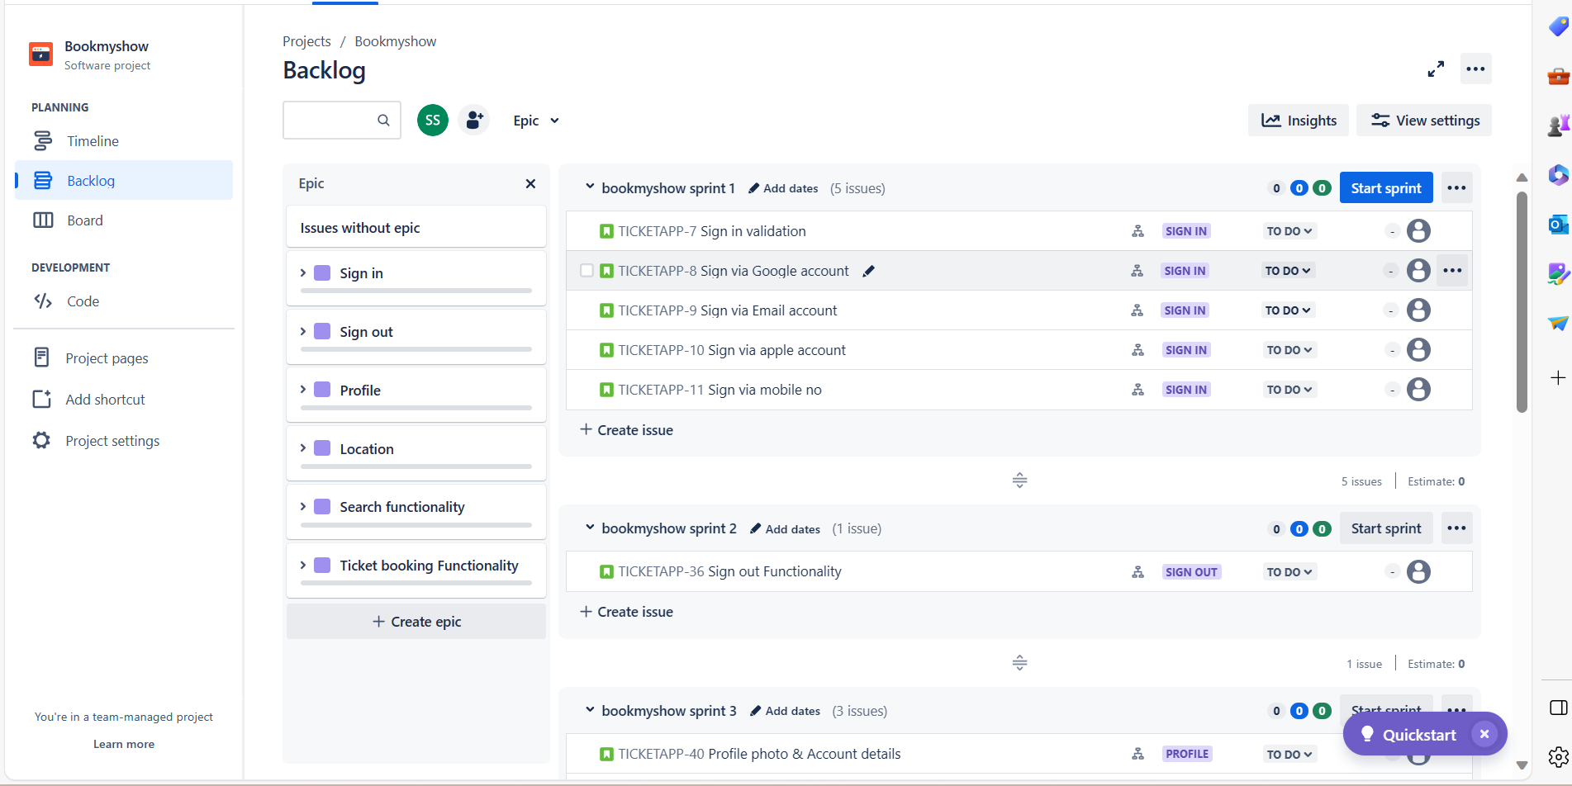

**EPIC 1: Sign in**

**User Story 1: Sign in Validation**

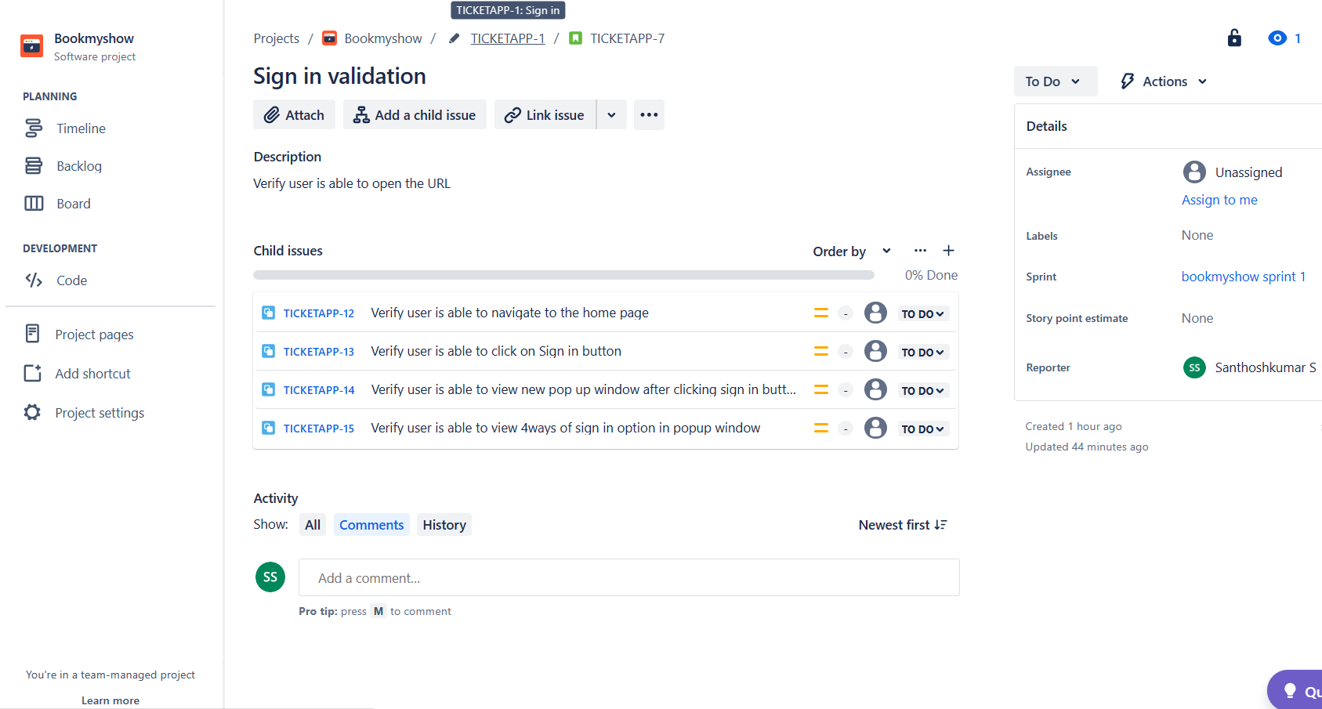

**EPIC 1: Sign in**

**User Story 2: Sign via Google Account**

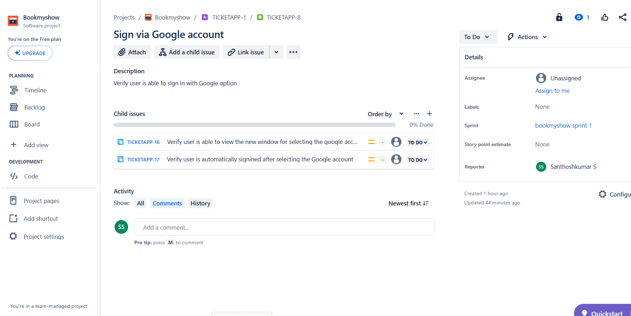

**EPIC 1: Sign in**

**User Story 3: Sign via Email Account**

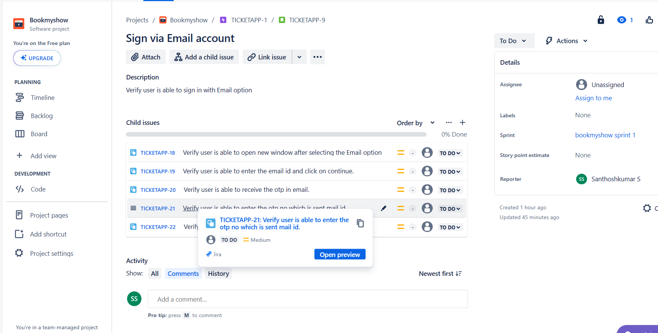

**EPIC 1: Sign in**

**User Story 4: Sign via apple account**

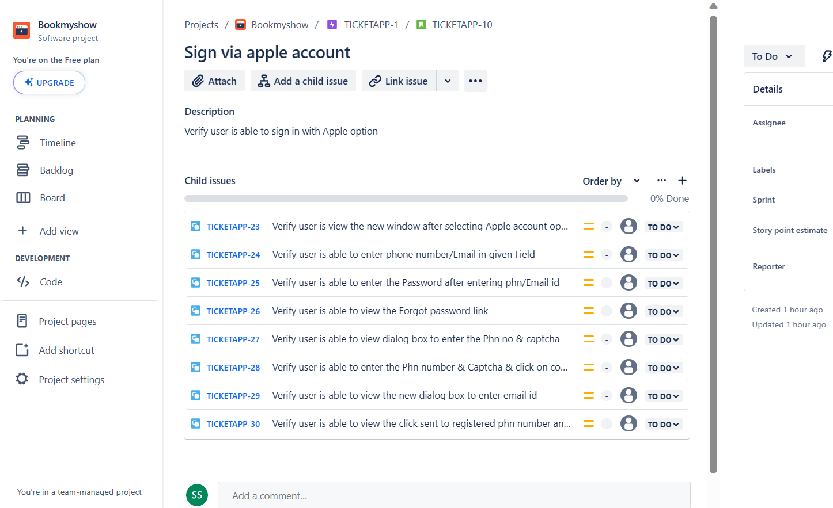

**EPIC 1: Sign in**

**User Story 5: Sign in via Mobile no.**

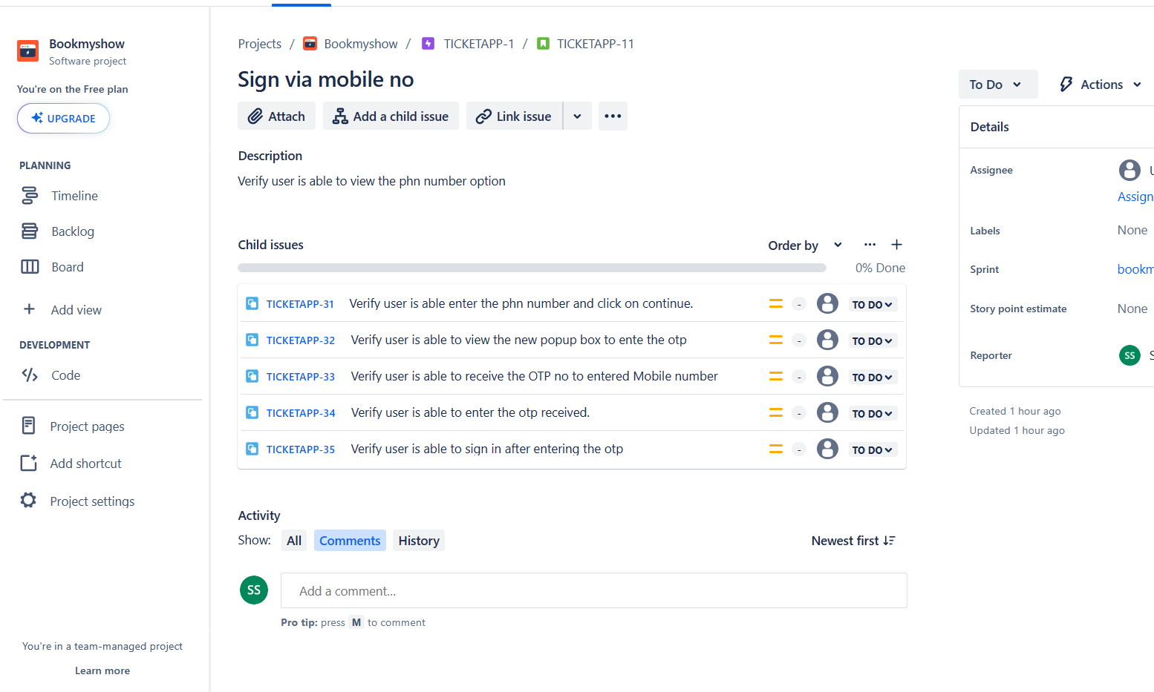

**EPIC 2: Sign out**

**User Story 6: Sign out Functionality**

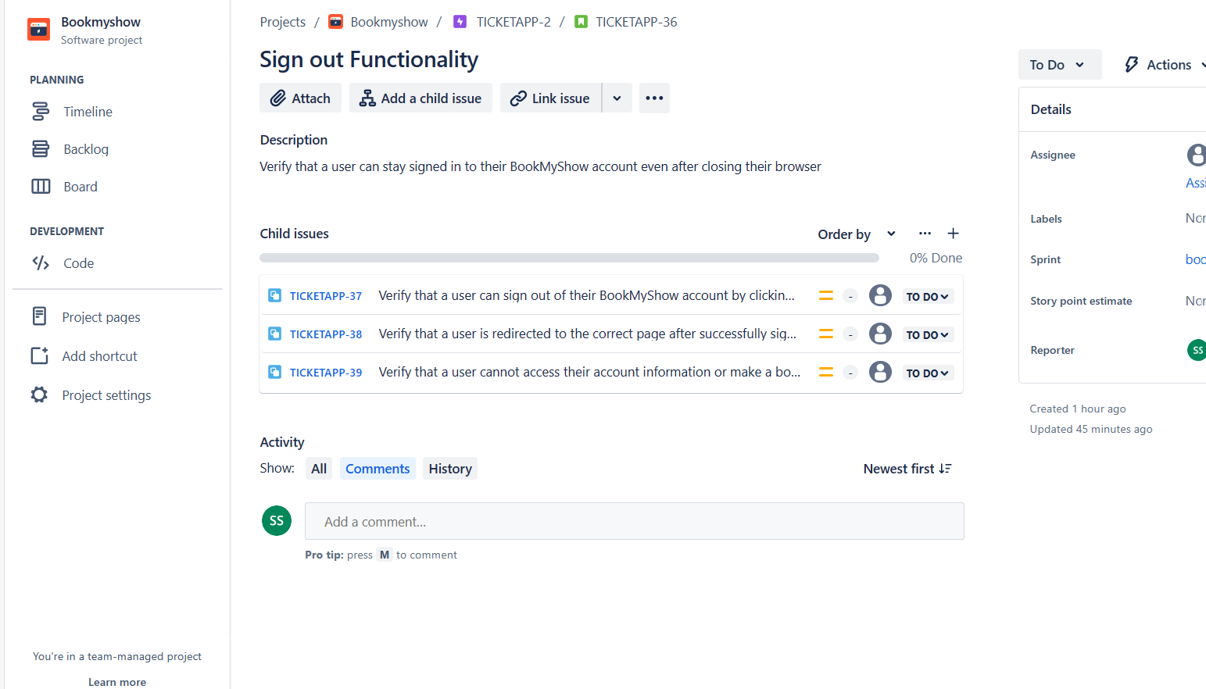

**EPIC 3: Profile**

**User Story 7: Profile photo & Account details**

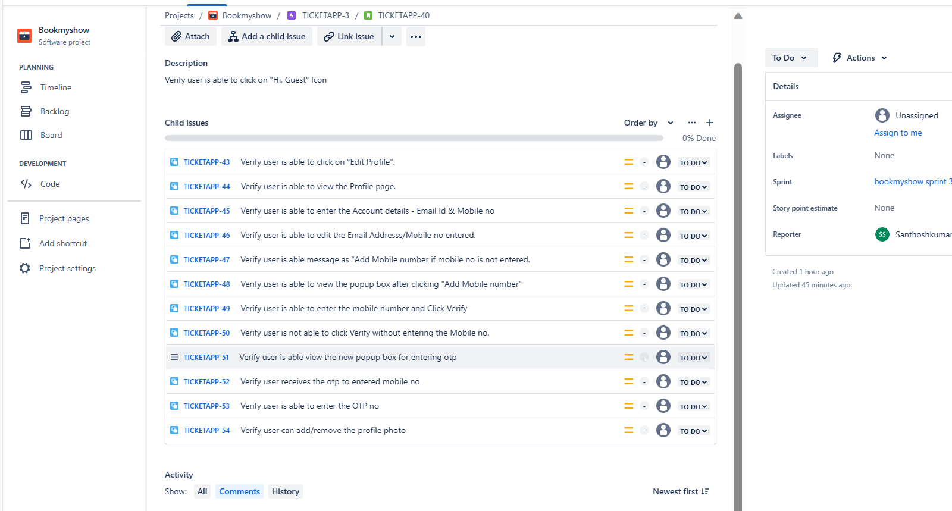

**EPIC 3: Profile**

**User Story 8: Personal details**

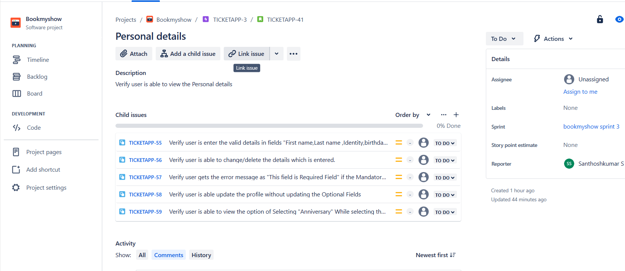

**EPIC 3: Profile**

**User Story 9: Address Details**

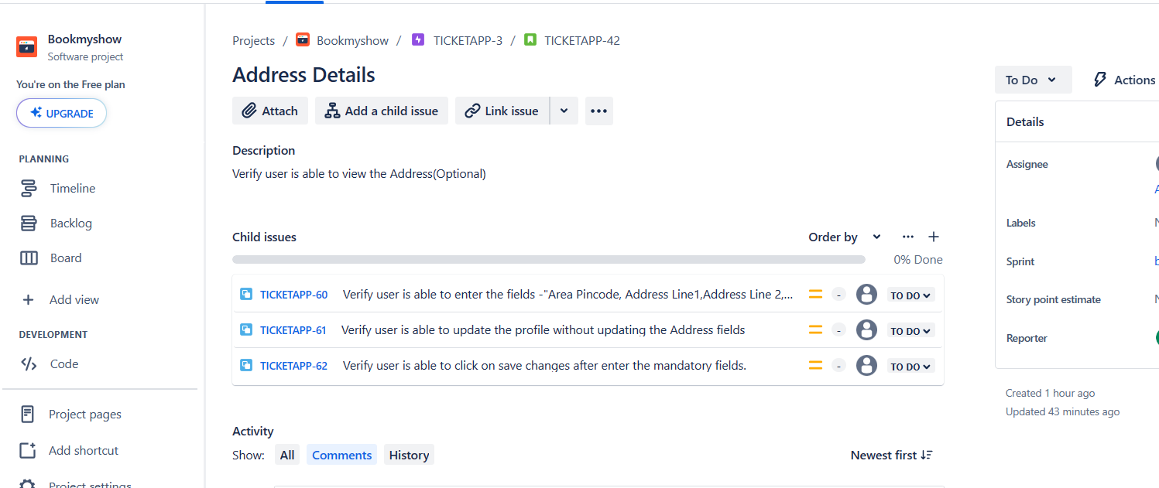

**EPIC 4: Location**

**User Story 10: Location Selection**

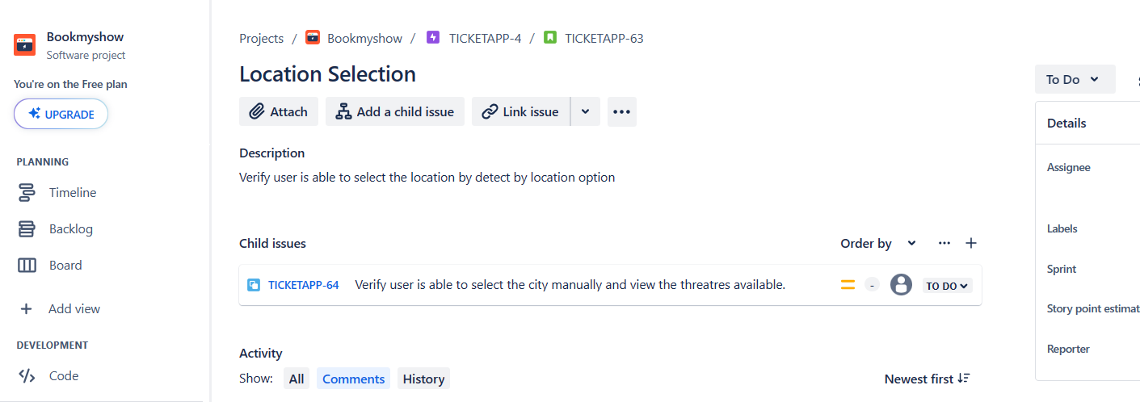

**EPIC 5: Search Functionality**

**User Story11: Search Option**

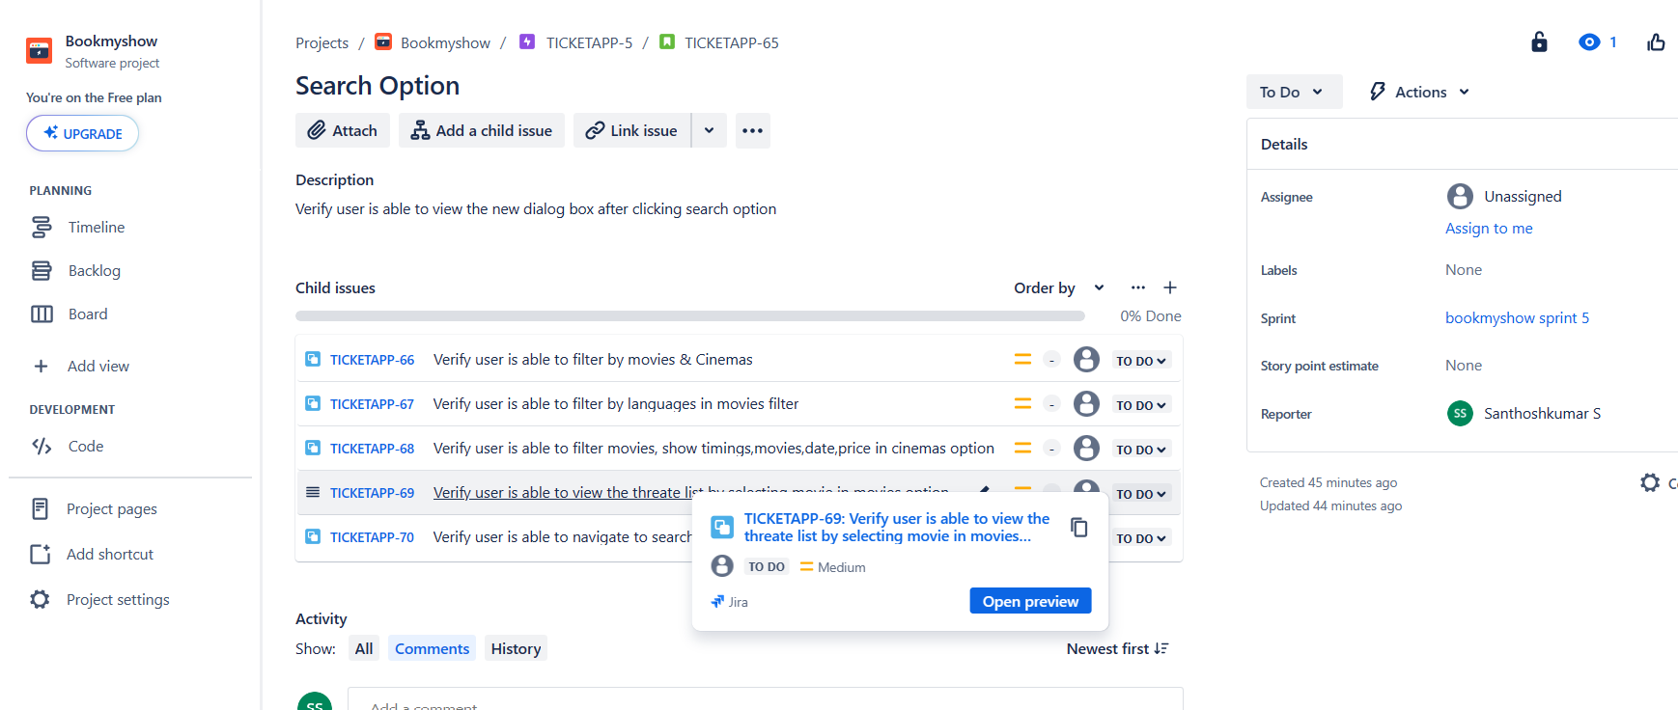

**EPIC 6: Ticket Booking Functionality**

**User Story12: Ticket Booking**

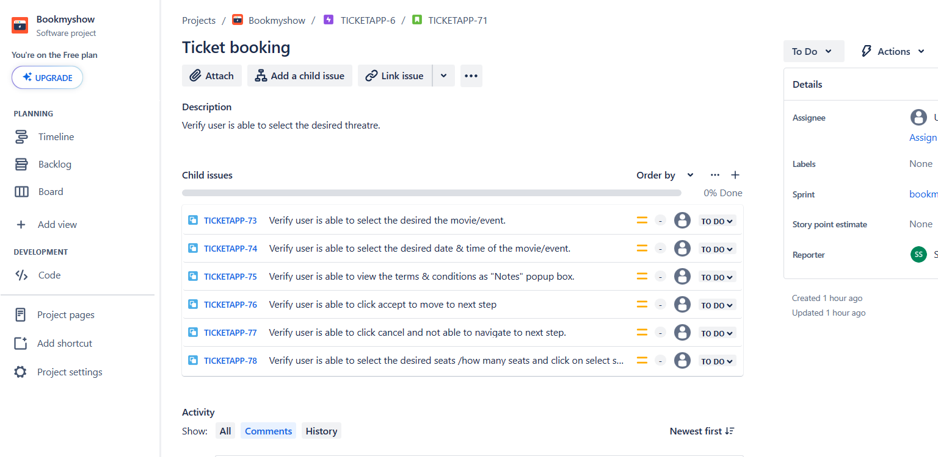

**EPIC 6: Ticket Booking Functionality**

**User Story12: Payment**

